**Transcript Evaluator**

1. First Install Java for your operating system (Windows, Linux, MacOS) from here: <https://www.java.com/en/download/>

How to install: https://www.youtube.com/watch?v=IJ-PJbvJBGs

1. After Installing Java open command prompt and go to location where you copied your code using cd command

1. After reaching directory where Program resides type “java Main.java”

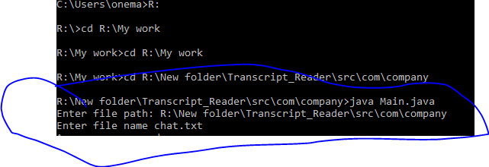

1. It will ask for chat transcript location enter file path.
2. Then it will ask for file name. Remember to write filename along with extension as shown in above snippet.
3. Press enter key if filename is correct, and location is correct it will show message “Successfully wrote in file.”
4. Open folder from windows where you placed your chat transcript another file will be present named “chat_output.txt”
5. This text file will have your required result.

In case of any bug or feedback. I would love to hear from you Reach me out at [rahimlions@gmail.com](mailto:rahimlions@gmail.com)